**C# Programming Lab Exercises - 1**

1. **Write a program to display a welcome message on the screen using String type variable declaration and assignment. Value of message should be entered from the keyboard.**

**Sol:** 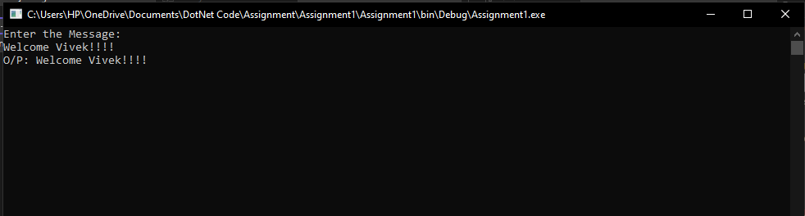

1. **Write a program to declare an integer variable and assign an integer value and display the same on the computer console.**

**Sol:** 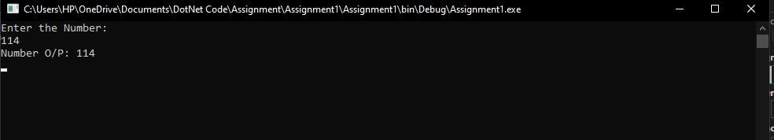

1. **Program to perform addition between two numbers. Numbers should be entered by the user.**

**Sol:** 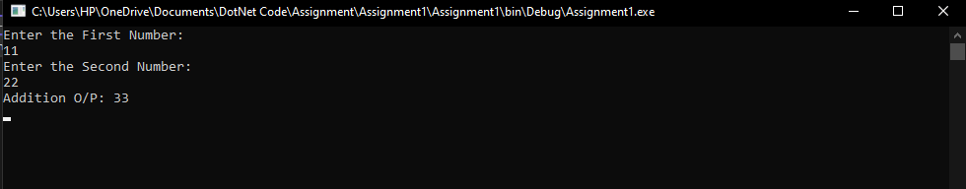

1. **Program to perform subtraction between two numbers. Numbers should be entered by the user**

**Sol:** 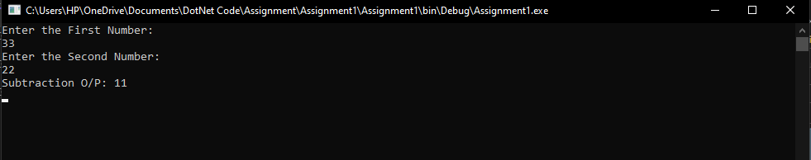

1. **Program to perform multiplication between two numbers. Numbers should be entered by the user**

**Sol:** 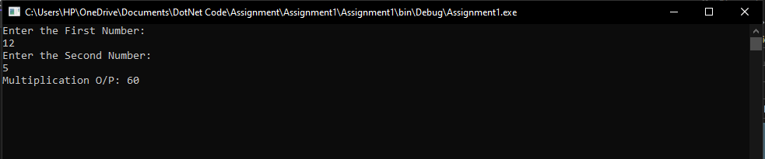

1. **Program to perform division between two numbers. Numbers should be entered by the user**

**Sol:** 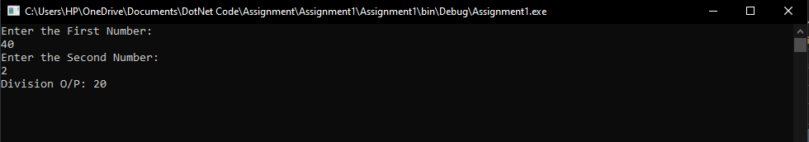

1. **Write a single program to perform all arithmetic operations. Numbers should be entered by the user**

* **Addition**
* **Subtraction**
* **Multiplication**
* **Division**

**Sol:** 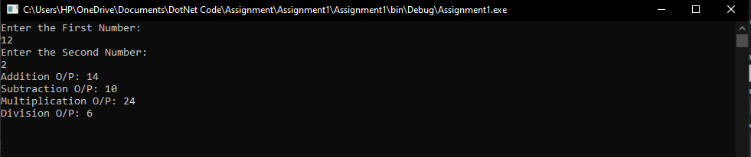

1. **Write a program (WAP) to calculate sum of three numbers. Numbers should be entered by the user**

**Sol:** 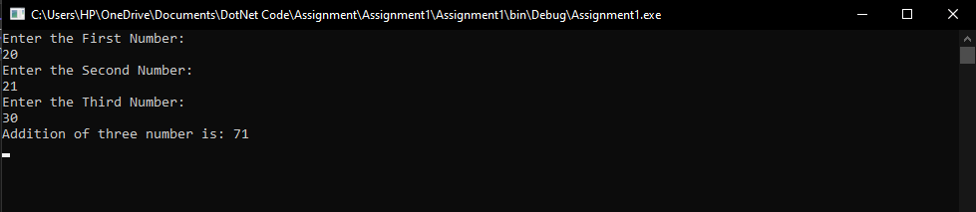

1. **Write a program to calculate average of three numbers. Numbers should be entered by the user**

**Sol:** 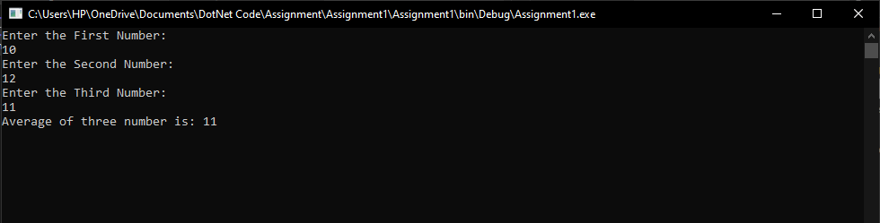

1. **Calculate Rectangle Area using C#. the value of length and width should be entered by the user.**

**Sol:** 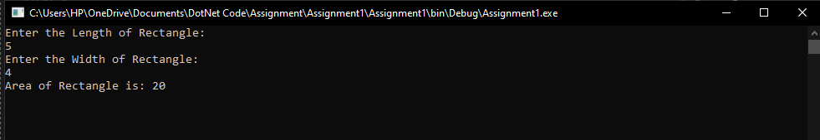

1. **Calculate Rectangle Perimeter using C#**

**Sol:** 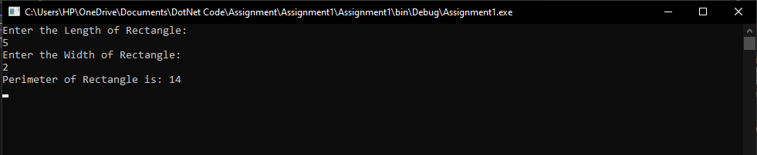

1. **Calculate Circle Area using C#**

**Sol:** 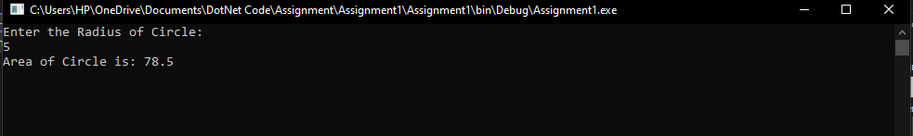

1. **Calculate Circle Perimeter using C#**

**Sol:** 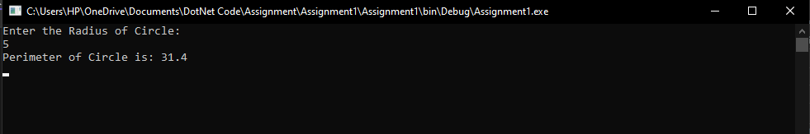

1. **Write a program to convert celcius to fahrenheit:**

**Sol:** 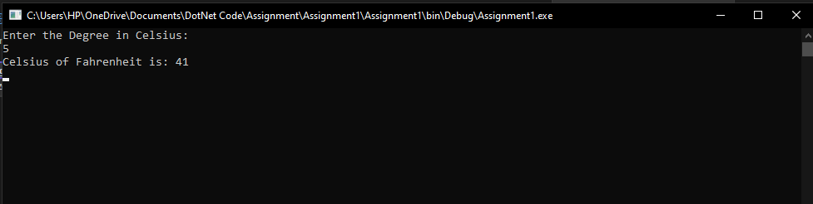

1. **Write a program to convert fahrenheit to celcius:**

**Sol:** 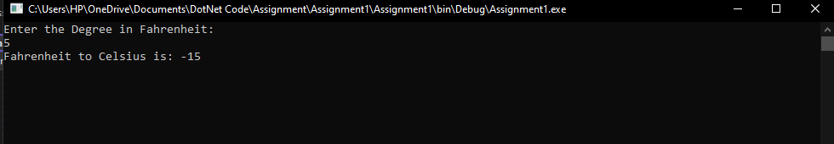

1. **Write a program to calculate simple interest .**

**Sol:** 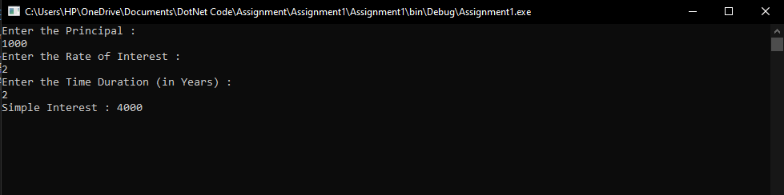

1. **write a program to calculate square of a number.**

**Sol:** 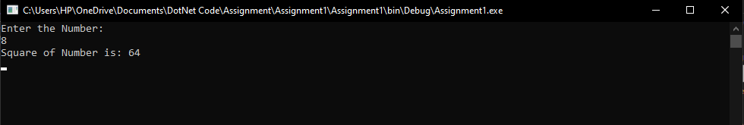

1. **write a program to calculate cube of a number.**

**Sol:** 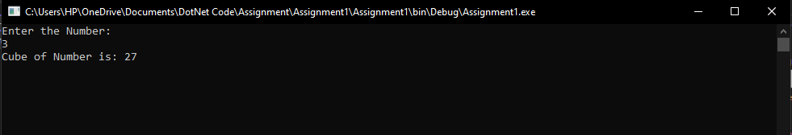

1. **Program to interchange the values of two variables using third variable.**

**Sol:** 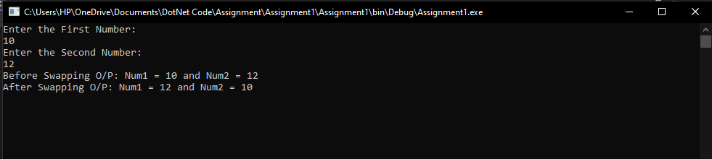

1. **Program to interchange the values of two variables without using third variable.**

**Sol:** 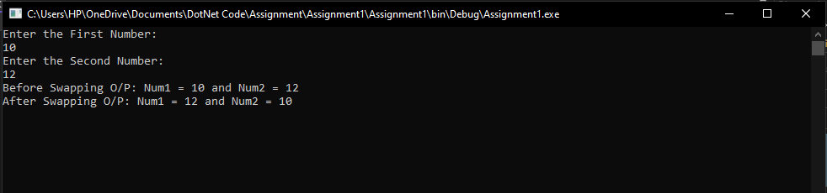

1. **Write a program that takes as input a four-digit number in format** abcd **(e.g. 2011) and performs the following actions:**
   * **Calculates the sum of the digits (in our example 2+0+1+1 = 4).**

**Sol:** 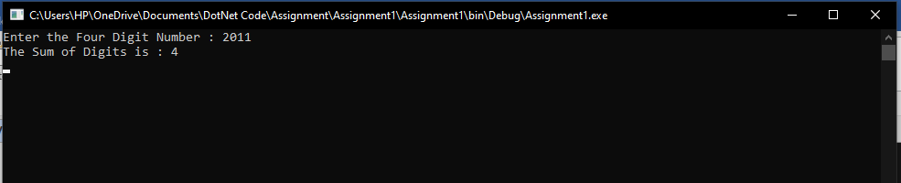

* + **Prints on the console the number in reversed order:** dcba **(in our example 1102).**

**Sol:** 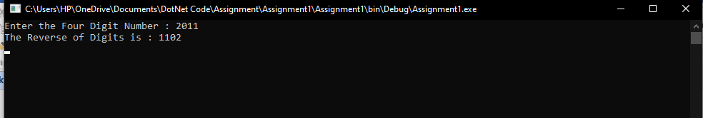

* + **Puts the last digit in the first position:** dabc **(in our example 1201).**

**Sol:** 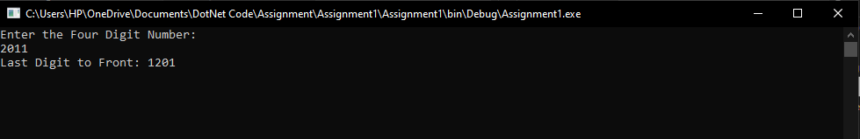

* + **Exchanges the second and the third digits:** acbd **(in our example 2101).**

**Sol:** 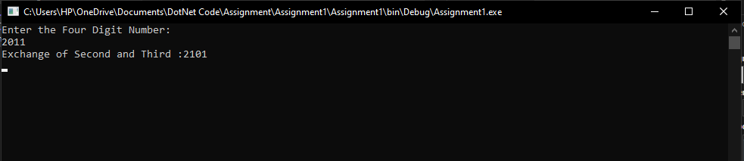

1. **WAP to welcome a user with his or her name**

**Sol:** 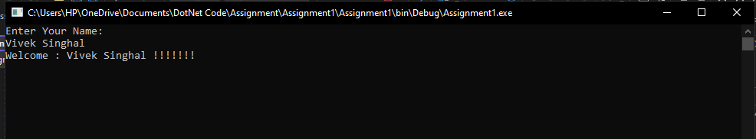

1. **WAP to display complete details of an employee using + operator: name, age, phone number, email-id, address etc.**

**Sol:** 